hp

[Email address]

Abstract

**In this project, we will focus only on sales data, and we need to create a data mart around  
product sales in stores.  
A data mart around sales will help the company generate actionable insights such as the following:  
• Total sales in a day/week/quarter (both in terms of sales revenue and units sold)  
• Top 5 most selling item categories in a day (both in terms of amount and quantity)  
• Top 5 most profitable items in a day/week/quarter  
• Top 5 most profitable stores in a day/week/month/quarter  
• Total profit or loss in U.S. dollars every day in percentage**

IndustrY GRADE Project

Forecasting Trends and Demand

**The Goal of the Project Below are some of the high-level goals of this project:**

• Get an overall understanding of the retail domain

• Learn the fundamentals & standards of ETL and data warehousing

• Real-time and batch ingestion of data from multiple sources to Big Data storage like Hive/HBase/HDFS using Kafka and Spark

• Data cleansing/wrangling/transformation using Hive and Spark • Lambda architecture where data can be processed in both batch and real-time

• Reporting KPIs using dashboards

**High -Level Flow**

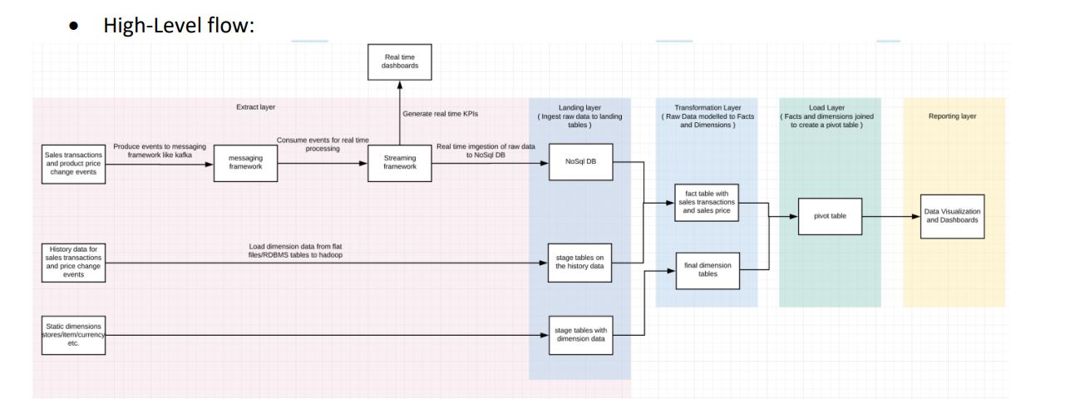

Forecasting Trends and Demand

[edureka_918210@ip-20-0-41-62 ~]$ hadoop fs -ls /bigdatapgp/common_folder/project_retailcart

Found 4 items

drwxr-xr-x - evaluationuser01 supergroup 0 2020-07-26 16:12 /bigdatapgp/common_folder/project_retailcart/batchdata

drwxr-xr-x - evaluationuser01 supergroup 0 2020-07-26 16:23 /bigdatapgp/common_folder/project_retailcart/connector_jars

drwxr-xr-x - evaluationuser01 supergroup 0 2020-07-26 16:19 /bigdatapgp/common_folder/project_retailcart/history_data

drwxr-xr-x - evaluationuser01 supergroup 0 2020-07-27 19:14 /bigdatapgp/common_folder/project_retailcart/realtimedata

[edureka_918210@ip-20-0-41-62 ~]$

FINAL TABLES DETAILS

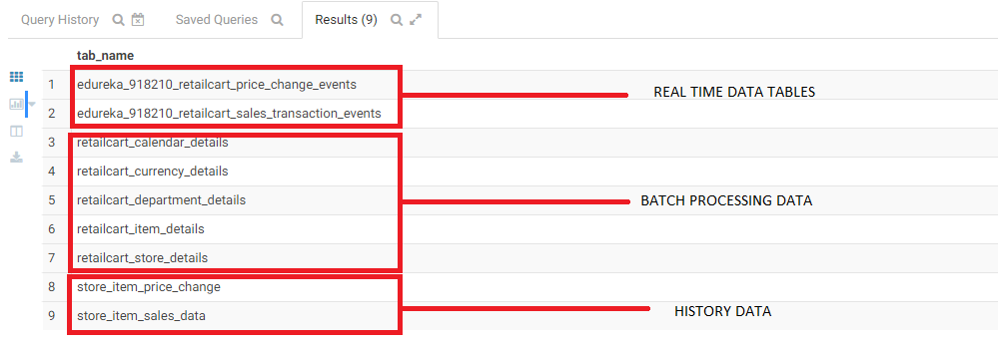

Please find above the tables , generated in 3 different Process Workflows:

1. Batch Data
2. History Data
3. Real Time Data

**Location Of the Scripts/Jar Details**

/mnt/home/edureka_918210/edureka_918210_retailcart

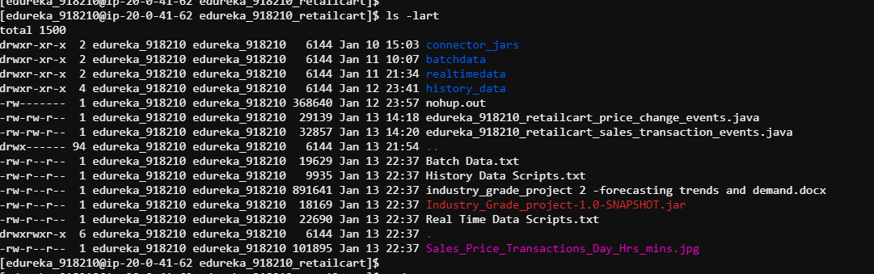

[edureka_918210@ip-20-0-41-62 project_retailcart]$ hadoop fs -ls /bigdatapgp/common_folder/project_retailcart/batchdata

Found 5 items

-rw-r--r-- 3 evaluationuser01 supergroup 1822863 2020-07-26 16:12 /bigdatapgp/common_folder/project_retailcart/batchdata/retailcart_calendar_details.txt

-rw-r--r-- 3 evaluationuser01 supergroup 1356 2020-07-26 16:12 /bigdatapgp/common_folder/project_retailcart/batchdata/retailcart_currency_details.txt

-rw-r--r-- 3 evaluationuser01 supergroup 271441 2020-07-26 16:12 /bigdatapgp/common_folder/project_retailcart/batchdata/retailcart_department_details.txt

-rw-r--r-- 3 evaluationuser01 supergroup 107275790 2020-07-26 16:12 /bigdatapgp/common_folder/project_retailcart/batchdata/retailcart_item_details.txt

-rw-r--r-- 3 evaluationuser01 supergroup 831617 2020-07-26 16:12 /bigdatapgp/common_folder/project_retailcart/batchdata/retailcart_store_details.txt

[edureka_918210@ip-20-0-41-62 project_retailcart]$

[edureka_918210@ip-20-0-41-62 project_retailcart]$ hadoop fs -ls /bigdatapgp/common_folder/project_retailcart/connector_jars

Found 1 items

-rw-r--r-- 3 evaluationuser01 supergroup 1006959 2020-07-26 16:23 /bigdatapgp/common_folder/project_retailcart/connector_jars/mysql-connector-java-5.1.48-bin.

jar

[edureka_918210@ip-20-0-41-62 project_retailcart]$

[edureka_918210@ip-20-0-41-62 project_retailcart]$ hadoop fs -ls /bigdatapgp/common_folder/project_retailcart/history_data

Found 2 items

drwxr-xr-x - evaluationuser01 supergroup 0 2020-07-26 16:18 /bigdatapgp/common_folder/project_retailcart/history_data/store_item_price_change

drwxr-xr-x - evaluationuser01 supergroup 0 2020-07-26 16:20 /bigdatapgp/common_folder/project_retailcart/history_data/store_item_sales_data

[edureka_918210@ip-20-0-41-62 project_retailcart]$

[edureka_918210@ip-20-0-41-62 project_retailcart]$ hadoop fs -ls /bigdatapgp/common_folder/project_retailcart/realtimedata

Found 2 items

-rw-r--r-- 3 evaluationuser01 supergroup 41546 2020-07-27 09:56 /bigdatapgp/common_folder/project_retailcart/realtimedata/price_change_event.txt

-rw-r--r-- 3 evaluationuser01 supergroup 5029 2020-07-27 16:42 /bigdatapgp/common_folder/project_retailcart/realtimedata/real_time_simulator.py

**RECORD INSERTED**

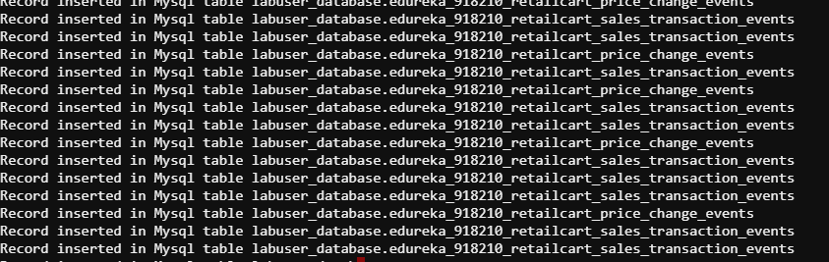

[edureka_918210@ip-20-0-41-62 project_retailcart]$

/bigdatapgp/common_folder/project_retailcart/batchdata/retailcart_calendar_details.txt

"calendar_date","date_desc","week_day_nbr","week_number","week_name","year_week_number","month_number","month_name","quarter_number","quarter_name","half_year_number","half_year_name","geo_region_cd"

[edureka_918210@ip-20-0-41-62 batchdata]$ hadoop fs -ls /user/edureka_918210/project_retailcart/batchdata

Found 1 items

-rw-r--r-- 3 edureka_918210 hadoop 1822689 2021-01-10 15:56 /user/edureka_918210/project_retailcart/batchdata/retailcart_calendar_details.txt

[edureka_918210@ip-20-0-41-62 batchdata]$

2011-02-20 Sunday, February 20, 2011 2 4 Week 04 201104 1 February 1 Q1 1 1st Half US

import org.apache.spark.ml.classification.LogisticRegression

import org.apache.spark.ml.evaluation.BinaryClassificationEvaluator

import org.apache.spark.ml.feature.{StringIndexer, VectorAssembler}

import org.apache.spark.ml.linalg.DenseVector

import org.apache.spark.mllib.evaluation.BinaryClassificationMetrics

import org.apache.spark.sql.SparkSession

import org.apache.log4j.Logger

import org.apache.log4j.Level

import org.apache.spark.ml.feature.{HashingTF, IDF, Tokenizer}

import org.apache.spark.ml.feature.QuantileDiscretizer

import org.apache.spark.sql.types._

import org.apache.spark.ml.classification.LogisticRegression

import org.apache.spark.ml.evaluation.BinaryClassificationEvaluator

import org.apache.spark.ml.feature.{StringIndexer, VectorAssembler}

import org.apache.spark.ml.feature.{HashingTF, IDF, Tokenizer}

import org.apache.spark.ml.linalg.DenseVector

import org.apache.spark.mllib.evaluation.BinaryClassificationMetrics

import org.apache.spark.sql.SparkSession

import org.apache.log4j.Logger

import org.apache.log4j.Level

import org.apache.spark.ml.feature.{HashingTF, IDF, Tokenizer}

import org.apache.spark.ml.feature.QuantileDiscretizer

import org.apache.spark.sql.types._

import org.apache.spark.ml.feature.MinMaxScaler

import org.apache.spark.ml.linalg.Vectors

import org.apache.spark.ml.classification.RandomForestClassifier

import org.apache.spark.ml.evaluation.MulticlassClassificationEvaluator

import org.apache.spark.ml.feature.StringIndexer

import org.apache.spark.ml.feature.VectorAssembler

import org.apache.spark.ml.classification.RandomForestClassifier

import org.apache.spark.ml.evaluation.MulticlassClassificationEvaluator

import org.apache.spark.ml.feature.StringIndexer

import org.apache.spark.ml.feature.VectorAssembler

import org.apache.spark.sql.functions._

import org.apache.spark.ml.feature.{OneHotEncoder, StringIndexer}

import org.apache.spark.ml.Pipeline

import org.apache.spark.ml.classification.{RandomForestClassificationModel, RandomForestClassifier}

import org.apache.spark.ml.evaluation.MulticlassClassificationEvaluator

import org.apache.spark.ml.feature.{IndexToString, StringIndexer, VectorIndexer}

import org.apache.spark.ml.evaluation.RegressionEvaluator

import org.apache.spark.ml.regression.LinearRegression

import org.apache.spark.ml.tuning.{ParamGridBuilder,TrainValidationSplit}

import org.apache.log4j._

import org.apache.spark.ml.feature.VectorAssembler

import org.apache.spark.mllib.linalg.Vectors

import org.apache.spark.ml.Pipeline

import org.apache.spark.ml.classification.LogisticRegression

import org.apache.spark.ml.evaluation.BinaryClassificationEvaluator

import org.apache.spark.ml.feature.{HashingTF, Tokenizer}

import org.apache.spark.ml.linalg.Vector

import org.apache.spark.ml.tuning.{CrossValidator, ParamGridBuilder}

import org.apache.spark.sql.Row

// $example off$

import org.apache.spark.sql.SparkSession

import org.apache.spark.sql.{Row, SparkSession}

import org.apache.spark.sql.types._

import org.apache.spark.sql.functions._

import org.apache.spark.sql.Row;

import org.apache.spark.sql.types.{StructType, StructField, StringType};

**retailcart_calendar_details**

"calendar_date date_desc week_day_nbr week_number week_name year_week_number month_number month_name quarter_number quarter_name half_year_number half_year_name geo_region_cd"

spark.read.textFile("/user/edureka_918210/project_retailcart/batchdata/retailcart_calendar_details.txt").createOrReplaceTempView("retailcart_calendar_details");

2011-02-20 Sunday, February 20, 2011 2 4 Week 04 201104 1 February 1 Q1 1 1st Half US

val retailcart_calendar =

spark.sql(""" Select

split(value,'\t')[0] as calendar_date,

split(value,'\t')[1] as date_desc,

split(value,'\t')[2] as week_day_nbr,

split(value,'\t')[3] as week_number,

split(value,'\t')[4] as week_name,

split(value,'\t')[5] as year_week_number,

split(value,'\t')[6] as month_number,

split(value,'\t')[7] as month_name,

split(value,'\t')[8] as quarter_number,

split(value,'\t')[9] as quarter_name,

split(value,'\t')[10] as half_year_number,

split(value,'\t')[11] as half_year_name,

split(value,'\t')[12] as geo_region_cd

from retailcart_calendar_details """)

val retailcart_calendar2 = retailcart_calendar.selectExpr("calendar_date", "date_desc", "cast(week_day_nbr as integer) week_day_nbr", "week_number", "week_name", "cast(year_week_number as integer) year_week_number","month_number","month_name","quarter_number","quarter_name","half_year_number","half_year_name","geo_region_cd")

**retailcart_department_details**

department_number department_category_number department_sub_catg_number department_description department_category_description department_sub_catg_desc geo_region_cd

spark.read.textFile("/user/edureka_918210/project_retailcart/batchdata/retailcart_department_details.txt").createOrReplaceTempView("retailcart_department_details");

val retailcart_department =

spark.sql(""" Select

split(value,'\t')[0] as department_number,

split(value,'\t')[1] as department_category_number,

split(value,'\t')[2] as department_sub_catg_number,

split(value,'\t')[3] as department_description,

split(value,'\t')[4] as department_category_description,

split(value,'\t')[5] as department_sub_catg_desc,

split(value,'\t')[6] as geo_region_cd

from retailcart_department_details """)

val retailcart_department2 = retailcart_department.selectExpr("cast(department_number as integer) department_number", "cast(department_category_number as integer) department_category_number", "cast(department_sub_catg_number as integer) department_sub_catg_number", "department_description", "department_category_description", "department_sub_catg_desc","geo_region_cd")

**retailcart_item_details**

item_id geo_region_cd item_description unique_product_cd unique_product_cd_desc department_number department_category_number department_sub_catg_number vendor_name vendor_number item_status_cd item_status_desc unit_cost

spark.read.textFile("/user/edureka_918210/project_retailcart/batchdata/retailcart_item_details.txt").createOrReplaceTempView("retailcart_item_details");

val retailcart_item =

spark.sql(""" Select

split(value,'\t')[0] as item_id,

split(value,'\t')[1] as geo_region_cd,

split(value,'\t')[2] as item_description,

split(value,'\t')[3] as unique_product_cd,

split(value,'\t')[4] as unique_product_cd_desc,

split(value,'\t')[5] as department_number,

split(value,'\t')[6] as department_category_number,

split(value,'\t')[7] as department_sub_catg_number,

split(value,'\t')[8] as vendor_name,

split(value,'\t')[9] as vendor_number,

split(value,'\t')[10] as item_status_cd,

split(value,'\t')[11] as item_status_desc,

split(value,'\t')[12] as unit_cost

from retailcart_item_details """)

182396492 US PR SV SH COC 7940045968 SUAVE SHAM dept-num:2 dept-catg-num:561 dept-sub-catg-num:1203 PUERTO RICO SUPPLIES GROUP

INC 77641 A ACTIVE 41.68

74277172 US REV CS POWDER-880 30997630008 REV POWDER dept-num:46 dept-catg-num:7112 dept-sub-catg-num:16006 REVLON INC 430

306 A ACTIVE NULL

val retailcart_item2 = retailcart_item.selectExpr("cast(item_id as integer) item_id", "geo_region_cd", "item_description", "unique_product_cd", "unique_product_cd_desc", "department_number","department_category_number","department_sub_catg_number","vendor_name","vendor_number","item_status_cd","item_status_desc","cast(unit_cost as double) unit_cost")

**retailcart_store_details**

store_id geo_region_cd store_name sub_division_name sub_division_number region_number region_name market_number market_name city_name open_date open_status_desc postal_cd state_prov_cd

spark.read.textFile("/user/edureka_918210/project_retailcart/batchdata/retailcart_store_details.txt").createOrReplaceTempView("retailcart_store_details");

val retailcart_store =

spark.sql(""" Select

split(value,'\t')[0] as store_id,

split(value,'\t')[1] as geo_region_cd,

split(value,'\t')[2] as store_name,

split(value,'\t')[3] as sub_division_name,

split(value,'\t')[4] as sub_division_number,

split(value,'\t')[5] as region_number,

split(value,'\t')[6] as region_name,

split(value,'\t')[7] as market_number,

split(value,'\t')[8] as market_name,

split(value,'\t')[9] as city_name,

split(value,'\t')[10] as open_date,

split(value,'\t')[11] as open_status_desc,

split(value,'\t')[12] as postal_cd,

split(value,'\t')[13] as state_prov_cd

from retailcart_store_details """)

val retailcart_store2 = retailcart_store.selectExpr("cast(store_id as integer) store_id", "geo_region_cd", "store_name", "sub_division_name", "sub_division_number", "region_number","region_name","market_number","market_name","city_name","open_date","open_status_desc","postal_cd","state_prov_cd")

**retailcart_currency_details**

currency_id currency_code currency_name usd_exchange_rate

spark.read.textFile("/user/edureka_918210/project_retailcart/batchdata/retailcart_currency_details.txt").createOrReplaceTempView("retailcart_currency_details");

val retailcart_currency =

spark.sql(""" Select

split(value,'\t')[0] as currency_id,

split(value,'\t')[1] as currency_code,

split(value,'\t')[2] as currency_name,

split(value,'\t')[3] as usd_exchange_rate

from retailcart_currency_details """)

val retailcart_currency2 = retailcart_currency.selectExpr("currency_id", "currency_code", "currency_name", "cast(usd_exchange_rate as double) usd_exchange_rate")

**TO SAVE THE SPARK DATAFRAME INTO MYSQL : the mysql connector jar file is downloaded and connected.**

spark2-shell --jars /mnt/home/edureka_918210/project_retailcart/connector_jars/mysql-connector-java-5.1.48-bin.jar

retailcart_calendar2.write.format("jdbc").option("url","jdbc:mysql://dbserver.edu.cloudlab.com/labuser_database").option("dbtable","retailcart_calendar2").option("user","edu_labuser").option("password","edureka").option("driver","com.mysql.jdbc.Driver").mode("overwrite").save

retailcart_department2.write.format("jdbc").option("url","jdbc:mysql://dbserver.edu.cloudlab.com/labuser_database").option("dbtable","retailcart_department2").option("user","edu_labuser").option("password","edureka").option("driver","com.mysql.jdbc.Driver").mode("overwrite").save

retailcart_item2.write.format("jdbc").option("url","jdbc:mysql://dbserver.edu.cloudlab.com/labuser_database").option("dbtable","retailcart_item2").option("user","edu_labuser").option("password","edureka").option("driver","com.mysql.jdbc.Driver").mode("overwrite").save

retailcart_store2.write.format("jdbc").option("url","jdbc:mysql://dbserver.edu.cloudlab.com/labuser_database").option("dbtable","retailcart_store2").option("user","edu_labuser").option("password","edureka").option("driver","com.mysql.jdbc.Driver").mode("overwrite").save

retailcart_currency2.write.format("jdbc").option("url","jdbc:mysql://dbserver.edu.cloudlab.com/labuser_database").option("dbtable","retailcart_currency2").option("user","edu_labuser").option("password","edureka").option("driver","com.mysql.jdbc.Driver").mode("overwrite").save

mysql -u edu_labuser -h dbserver.edu.cloudlab.com -p

password - edureka

CREATE TABLE retailcart_calendar_details SELECT * FROM retailcart_calendar2;

CREATE TABLE retailcart_department_details SELECT * FROM retailcart_department2;

CREATE TABLE retailcart_item_details SELECT * FROM retailcart_item2;

CREATE TABLE retailcart_store_details SELECT * FROM retailcart_store2;

CREATE TABLE retailcart_currency_details SELECT * FROM retailcart_currency2;

**MYSQL TO HIVE**

sqoop import --connect jdbc:mysql://dbserver.edu.cloudlab.com/labuser_database --table retailcart_calendar_details -m 2 --hive-import --username edu_labuser --hive-database edureka_918210_DB_Industry_projects --split-by calendar_date --password edureka

sqoop import --connect jdbc:mysql://dbserver.edu.cloudlab.com/labuser_database --table retailcart_department_details -m 2 --hive-import --username edu_labuser --hive-database edureka_918210_DB_Industry_projects --split-by department_number --password edureka

sqoop import --connect jdbc:mysql://dbserver.edu.cloudlab.com/labuser_database --table retailcart_item_details -m 2 --hive-import --username edu_labuser --hive-database edureka_918210_DB_Industry_projects --split-by item_id --password edureka

sqoop import --connect jdbc:mysql://dbserver.edu.cloudlab.com/labuser_database --table retailcart_store_details -m 2 --hive-import --username edu_labuser --hive-database edureka_918210_DB_Industry_projects --split-by store_id --password edureka

sqoop import --connect jdbc:mysql://dbserver.edu.cloudlab.com/labuser_database --table retailcart_currency_details -m 2 --hive-import --username edu_labuser --hive-database edureka_918210_DB_Industry_projects --split-by currency_id --password edureka

**HISTORY DATA**

**4.2 History data for sales transactions and price change events:**

**Store_Item_Price_Change**

val spark = SparkSession.builder().appName("Industry_Grade_Project-spark").master("local[*]").enableHiveSupport().getOrCreate();

val store_item_price_change = spark.read.orc("/bigdatapgp/common_folder/project_retailcart/history_data/store_item_price_change")

scala> store_item_price_change.printSchema

root

|-- _col0: integer (nullable = true)

|-- _col1: integer (nullable = true)

|-- _col2: timestamp (nullable = true)

|-- _col3: string (nullable = true)

|-- _col4: string (nullable = true)

|-- _col5: date (nullable = true)

|-- _col6: decimal(15,2) (nullable = true)

|-- _col7: decimal(15,2) (nullable = true)

val store_item_price_change2 = store_item_price_change.toDF("item_id","store_id","price_chng_activation_ts","geo_region_cd","price_change_reason","business_date","prev_price_amt","curr_price_amt")

scala> store_item_price_change2.printSchema

root

|-- item_id: integer (nullable = true)

|-- store_id: integer (nullable = true)

|-- price_chng_activation_ts: timestamp (nullable = true)

|-- geo_region_cd: string (nullable = true)

|-- price_change_reason: string (nullable = true)

|-- business_date: date (nullable = true)

|-- prev_price_amt: decimal(15,2) (nullable = true)

|-- curr_price_amt: decimal(15,2) (nullable = true)

**SPARK TO HIVE**

**Store_item_price_change**

store_item_price_change2.write.mode("overwrite").saveAsTable("edureka_918210_DB_Industry_projects.store_item_price_change")

scala> spark.sql("select * from edureka_918210_DB_Industry_projects.store_item_price_change limit 10").show()

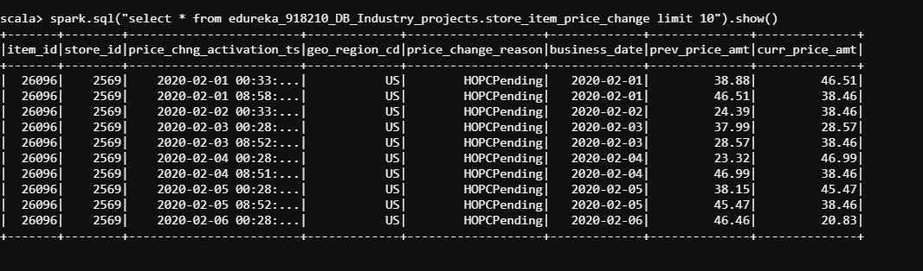

scala> spark.sql("select count(*) from edureka_918210_DB_Industry_projects.store_item_price_change").show()

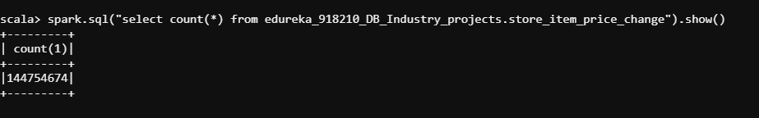

**Store_item_sales_data**

val spark = SparkSession.builder().appName("Industry_Grade_Project-spark").master("local[*]").enableHiveSupport().getOrCreate();

val store_item_sales_data = spark.read.orc("/bigdatapgp/common_folder/project_retailcart/history_data/store_item_sales_data")

scala> store_item_sales_data.printSchema

root

|-- _col0: integer (nullable = true)

|-- _col1: date (nullable = true)

|-- _col2: integer (nullable = true)

|-- _col3: integer (nullable = true)

|-- _col4: byte (nullable = true)

|-- _col5: string (nullable = true)

|-- _col6: string (nullable = true)

|-- _col7: integer (nullable = true)

|-- _col8: decimal(9,2) (nullable = true)

|-- _col9: date (nullable = true)

|-- _col10: string (nullable = true)

|-- _col11: short (nullable = true)

val store_item_sales_data2 = store_item_sales_data.toDF("sales_id","Sales_date","store_id","item_id","scan_type","geo_region_cd","currency_code","scan_id","sold_unit_quantity","scan_date","scan_time","scan_dept_nbr")

scala> store_item_sales_data2.printSchema

root

|-- sales_id: integer (nullable = true)

|-- Sales_date: date (nullable = true)

|-- store_id: integer (nullable = true)

|-- item_id: integer (nullable = true)

|-- scan_type: byte (nullable = true)

|-- geo_region_cd: string (nullable = true)

|-- currency_code: string (nullable = true)

|-- scan_id: integer (nullable = true)

|-- sold_unit_quantity: decimal(9,2) (nullable = true)

|-- scan_date: date (nullable = true)

|-- scan_time: string (nullable = true)

|-- scan_dept_nbr: short (nullable = true)

=======================================================================================================

SPARK TO Hive

store_item_sales_data2.write.mode("overwrite").saveAsTable("edureka_918210_DB_Industry_projects.store_item_sales_data")

spark.sql("select * from edureka_918210_DB_Industry_projects.store_item_sales_data limit 10").show()

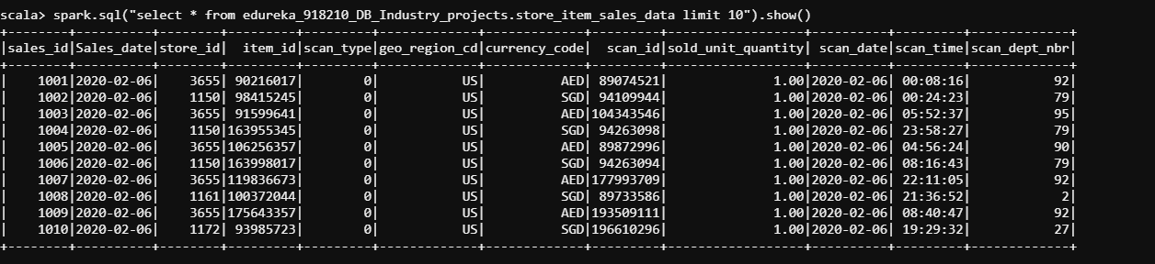

scala> spark.sql("select count(*) from edureka_918210_DB_Industry_projects.store_item_sales_data").show()

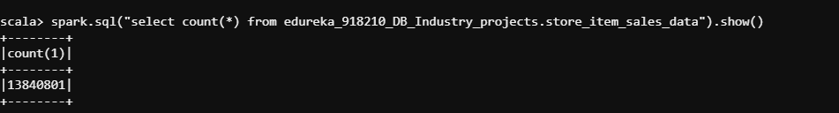

*********************************************************************************************************************

scala> spark.sql("Show tables in edureka_918210_DB_Industry_projects").show(false)

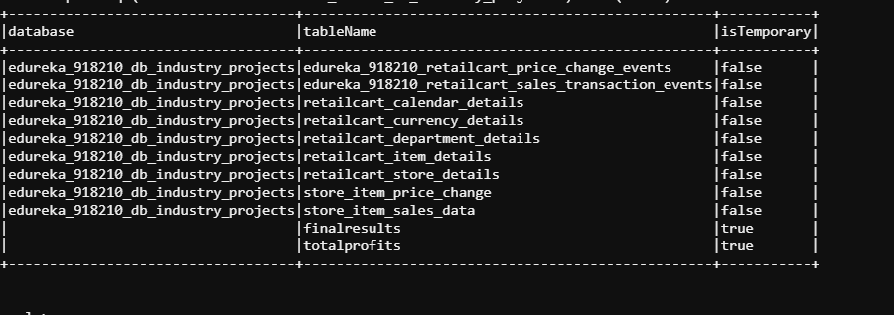

********************************************************************************************************************.

**REAL TIME DATA**

/mnt/home/edureka_918210/project_retailcart/realtimedata

[edureka_918210@ip-20-0-41-164 realtimedata]$ pwd

/mnt/home/edureka_918210/project_retailcart/realtimedata

[edureka_918210@ip-20-0-41-164 realtimedata]$

[edureka_918210@ip-20-0-41-164 realtimedata]$ ls -lart

total 60

-rwxr-xr-x 1 edureka_918210 edureka_918210 41546 Jan 10 15:03 price_change_event.txt

-rwxr-xr-x 1 edureka_918210 edureka_918210 5029 Jan 10 15:03 real_time_simulator.py

drwxr-xr-x 2 edureka_918210 edureka_918210 6144 Jan 10 15:03 .

python2 realtimedata/real_time_simulator.py edureka_918210

labuser_database.username_retailcart_sales_transaction_events

labuser_database.username_retailcart_price_change_events

mysql -u edu_labuser -h dbserver.edu.cloudlab.com -p

password - edureka

DB - labuser_database

MySQL [labuser_database]> describe edureka_918210_retailcart_price_change_events

-> ;

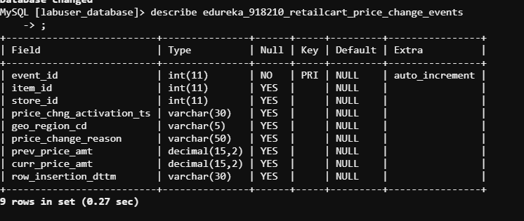

MySQL [labuser_database]> select count(*) from edureka_918210_retailcart_price_change_events

-> ;

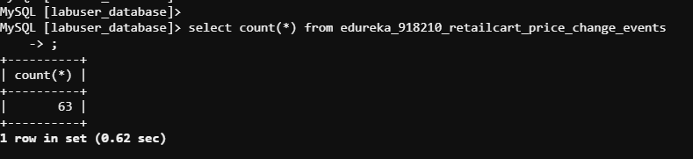

MySQL [labuser_database]>

MySQL [labuser_database]>

MySQL [labuser_database]> describe edureka_918210_retailcart_sales_transaction_events

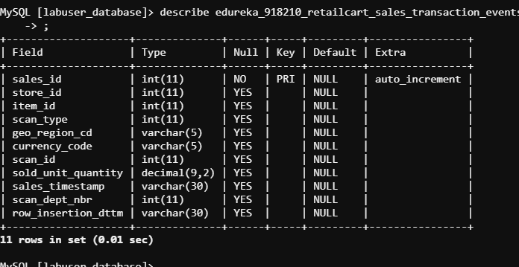

MySQL [labuser_database]>

MySQL [labuser_database]> select count(*) from edureka_918210_retailcart_sales_transaction_events;

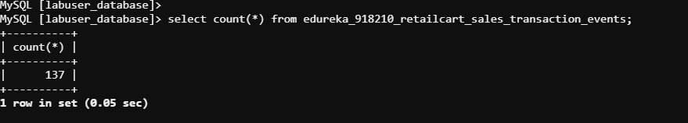

MySQL [labuser_database]>

LOCATION

/mnt/home/edureka_918210/project_retailcart/history_data - File Location

flume1.conf - File Name

SPARK STREAMING - FLUME

agent.channels.ch1.type = memory

agent.sources.sql-source.channels = ch1

agent.channels = ch1

agent.sinks = HDFS

agent.sources = sql-source

agent.sources.sql-source.type = org.keedio.flume.source.SQLSource

agent.sources.sql-source.connection.url = jdbc:mysql://dbserver.edu.cloudlab.com/labuser_database

agent.sources.sql-source.user = edu_labuser

agent.sources.sql-source.password = edureka

agent.sources.sql-source.table = labuser_database.edureka_918210_retailcart_sales_transaction_events

agent.sources.sql-source.columns.to.select = *

agent.sources.sql-source.incremental.column.name = sales_id

agent.sources.sql-source.run.query.delay=5000

agent.sinks.HDFS.channel = ch1

agent.sinks.HDFS.type = hdfs

agent.sinks.HDFS.hdfs.path = hdfs://nameservice1/user/edureka_918210/project_retailcart

agent.sinks.HDFS.hdfs.fileType = DataStream

agent.sinks.HDFS.hdfs.writeFormat = Text

agent.sinks.HDFS.hdfs.rollSize = 268435456

agent.sinks.HDFS.hdfs.rollInterval = 0

agent.sinks.HDFS.hdfs.rollCount = 0

**COMMANDS :**

**FLUME CONFIGURATION :**

nohup flume-ng agent -n a1 -f /mnt/home/edureka_918210/project_retailcart/history_data/flume1.conf -Dflume.root.logger=INFO,console &

nohup flume-ng agent -n a1 -f /mnt/home/edureka_918210/project_retailcart/history_data/flume1.conf -Dflume.root.logger=INFO,console & --- for labuser_database.edureka_918210_retailcart_price_change_events

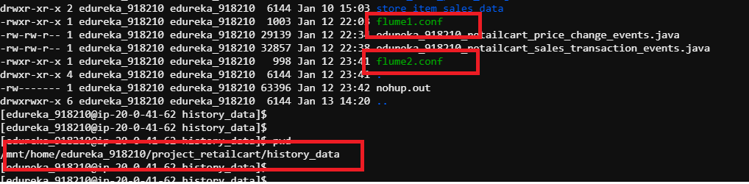

**FLUME Logger**

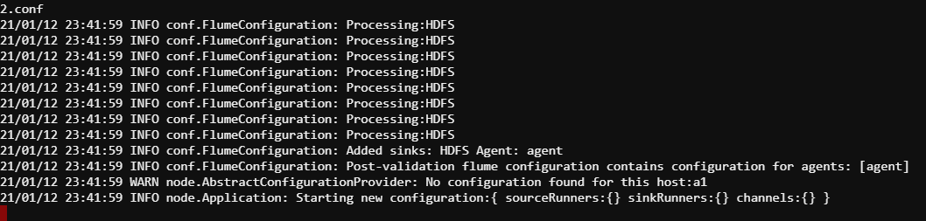

**hive tables from mysql**

sqoop import --connect jdbc:mysql://dbserver.edu.cloudlab.com/labuser_database \

--username edu_labuser \

--P \

--split-by event_id \

--columns event_id,item_id,store_id,price_chng_activation_ts,geo_region_cd,price_change_reason,prev_price_amt,curr_price_amt,row_insertion_dttm \

--table edureka_918210_retailcart_price_change_events \

--target-dir /user/edureka_918210/project_retailcart/edureka_918210_retailcart_price_change_events \

--fields-terminated-by "," \

--hive-import \

--create-hive-table \

--hive-table edureka_918210_DB_Industry_projects.edureka_918210_retailcart_price_change_events

sqoop import --connect jdbc:mysql://dbserver.edu.cloudlab.com/labuser_database \

--username edu_labuser \

--P \

--split-by sales_id \

--columns sales_id,store_id,item_id,scan_type,geo_region_cd,currency_code,scan_id,sold_unit_quantity,sales_timestamp,scan_dept_nbr,row_insertion_dttm \

--table edureka_918210_retailcart_sales_transaction_events \

--target-dir /user/edureka_918210/project_retailcart/edureka_918210_retailcart_sales_transaction_events \

--fields-terminated-by "," \

--hive-import \

--create-hive-table \

--hive-table edureka_918210_DB_Industry_projects.edureka_918210_retailcart_sales_transaction_events

/user/edureka_918210/edureka_918210_retailcart_price_change_events

/user/edureka_918210/edureka_918210_retailcart_sales_transaction_events

spark.sql("select * from edureka_918210_DB_Industry_projects.edureka_918210_retailcart_price_change_events").show(false)

spark.sql("select * from edureka_918210_DB_Industry_projects.edureka_918210_retailcart_sales_transaction_events").show(false)

**MYSQL TO HBase**

sqoop import --connect jdbc:mysql://dbserver.edu.cloudlab.com/labuser_database --table edureka_918210_retailcart_sales_transaction_events --hbase-table 'edureka_918210_retailcart_sales_transaction_events' --column-family cf2 --username edu_labuser --hbase-create-table --columns sales_id,store_id,item_id,scan_type,geo_region_cd,currency_code,scan_id,sold_unit_quantity,sales_timestamp,scan_dept_nbr,row_insertion_dttm --hbase-row-key sales_id -m 1 --password edureka

sqoop import --connect jdbc:mysql://dbserver.edu.cloudlab.com/labuser_database --table edureka_918210_retailcart_price_change_events --hbase-table 'edureka_918210_retailcart_price_change_events' --column-family cf2 --username edu_labuser --hbase-create-table --columns event_id,item_id,store_id,price_chng_activation_ts,geo_region_cd,price_change_reason,prev_price_amt,curr_price_amt,row_insertion_dttm --hbase-row-key event_id -m 1 --password edureka

**SAVE TO DF and CREATE JOINS**

val edureka_918210_retailcart_price_change_events_DF = spark.sql("select * from edureka_918210_DB_Industry_projects.edureka_918210_retailcart_price_change_events")

val edureka_918210_retailcart_sales_transaction_events_DF = spark.sql("select * from edureka_918210_DB_Industry_projects.edureka_918210_retailcart_sales_transaction_events")

val JoinDF = edureka_918210_retailcart_price_change_events_DF.join(edureka_918210_retailcart_sales_transaction_events_DF,"item_id").select("item_id","price_chng_activation_ts","sales_timestamp","curr_price_amt")

scala> JoinDF.printSchema

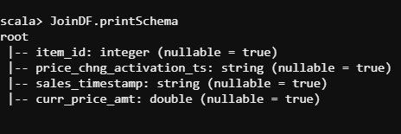

val JoinDF2 = JoinDF.selectExpr("item_id","cast(price_chng_activation_ts as timestamp) start_time","cast(sales_timestamp as timestamp) end_time","curr_price_amt")

scala> JoinDF2.show(5)

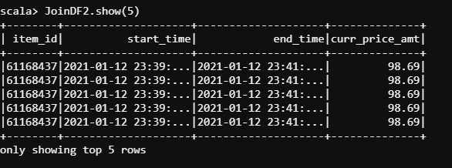

val JoinDF3 = JoinDF2.join(edureka_918210_retailcart_sales_transaction_events_DF,"item_id").select("item_id","store_id","start_time","end_time","curr_price_amt")

scala> JoinDF3.printSchema

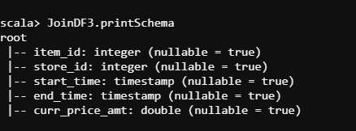

scala> JoinDF3.repartition(1).write.format("csv").save("/user/edureka_918210/project_retailcart/sales_result")

[edureka_918210@ip-20-0-41-164 project_retailcart]$ hadoop fs -ls /user/edureka_918210/project_retailcart/sales_result

Found 2 items

-rw-r--r-- 3 edureka_918210 hadoop 0 2021-01-13 16:24 /user/edureka_918210/project_retailcart/sales_result/_SUCCESS

-rw-r--r-- 3 edureka_918210 hadoop 1816227 2021-01-13 16:24 /user/edureka_918210/project_retailcart/sales_result/part-00000-6b1e7c7b-d602-4671-aa76-4d2daf53b5

b8.csv

[edureka_918210@ip-20-0-41-164 project_retailcart]$

[edureka_918210@ip-20-0-41-164 project_retailcart]$

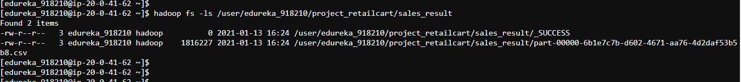

**OBJECTIVES :**

Total sales in a day/week/quarter (both in terms of sales revenue and units sold)

• Top 5 most selling item categories in a day (both in terms of amount and quantity)

• Top 5 most profitable items in a day/week/quarter

• Top 5 most profitable stores in a day/week/month/quarter

• Total profit or loss in U.S. dollars every day in percentage

Top 5 most selling item categories in a day (both in terms of amount and quantity)

======================================================================================

scala> JoinDF3.printSchema

val results = JoinDF3.withColumn("date", to_date($"start_time"))

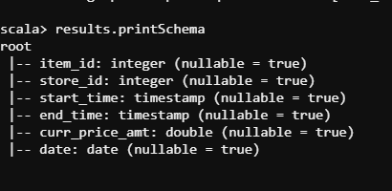

scala> results.groupBy("item_id","date").count().orderBy("count").show(false)

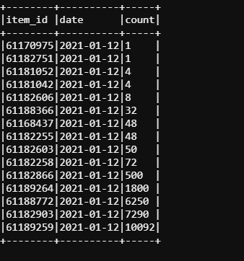

• Top 5 most profitable items in a day/week/quarter

=========================================================

val results2 = results.groupBy("item_id","date","curr_price_amt").count().orderBy("count")

scala> results2.printSchema

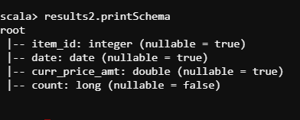

val results3 = results2.selectExpr("item_id","date","curr_price_amt","cast(count as double) count")

val results4 = results3.selectExpr("item_id","date","curr_price_amt","count","curr_price_amt * count")

scala> results4.show(10)

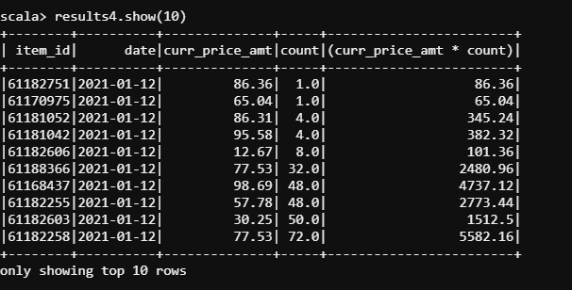

**Top 5 most profitable stores in a day/week/month/quarter**

JoinDF3.printSchema

results4.printSchema

val JoinDF4 = JoinDF3.selectExpr("item_id","store_id")

val Final = results4.join(JoinDF4,"item_id").select("item_id","date","curr_price_amt","count","(curr_price_amt * count)","store_id")

scala> Final.show(10)

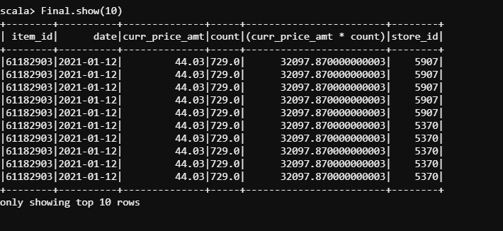

Final.createOrReplaceTempView("FinalResults")

spark.sql("Describe FinalResults").show(false)

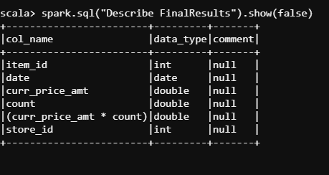

scala> spark.sql("SELECT item_id,count(item_id),sum((curr_price_amt * count)) as Total FROM FinalResults GROUP BY item_id ORDER BY TOTAL desc").show(false)

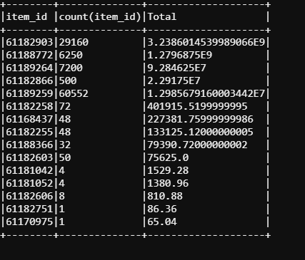

val df1 = spark.sql("SELECT item_id,count(item_id),sum((curr_price_amt * count)) as Total FROM FinalResults GROUP BY item_id ORDER BY TOTAL desc")

scala> df1.printSchema

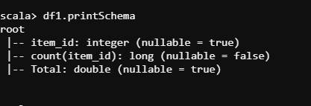

val df2 = Final.selectExpr("item_id","store_id")

scala> df2.printSchema

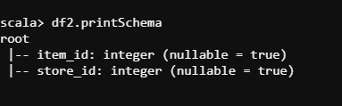

val Final_Results = df2.join(df1,"item_id").distinct()

**Top 5 most profitable stores in a day/week/month/quarter**

scala> Final_Results.show(false)

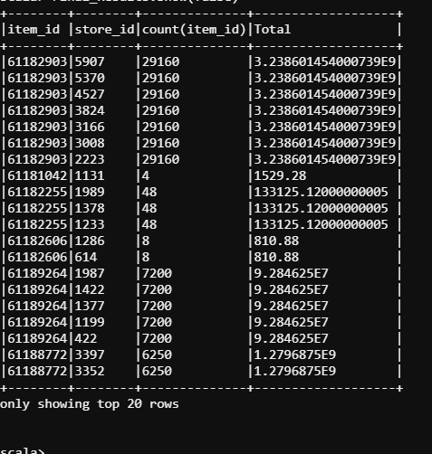

**• Total profit or loss in U.S. dollars every day in percentage**

scala> results4.printSchema

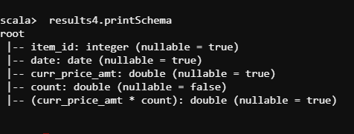

val results5 = results4.selectExpr("item_id","date")

scala> Final_Results.printSchema

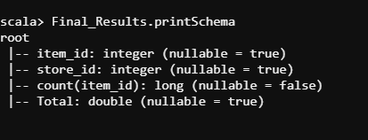

val Final_Results2 = Final_Results.join(results5,"item_id").distinct()

Final_Results2.createOrReplaceTempView("totalprofits")

val TotalAmountInaDay = spark.sql("select date,sum(Total) from totalprofits group by date")

scala> TotalAmountInaDay.show(false)

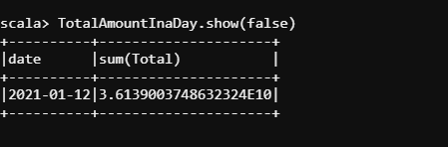

**TABLEAU REPRESENTATION OF SALES PRICE IN A DAY/WEEK/MONTH**

